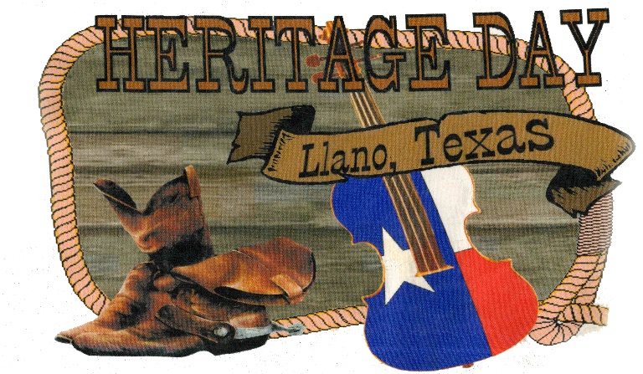
Entertainer Application
If you would like to be an entertainer at the 2024 Llano Heritage Days Festival in Llano, Texas, please complete the application and email it to:
Cristele.richins@gmail.com or virginiarosewalker@yahoo.com
For additional information contact the Llano County Museum at
325-247-3026 Thursday-Saturday

Name:________________________________________________________
Email:_________________________________________________________
Phone_________________________________________________________

Type of entertainment you perform:

Do you need a stage?________
Do you need a sound system?________________
Do you stroll through the attendees?_________________
What do you charge?___________________________________
Do you have your own liability insurance?________________How much?______

