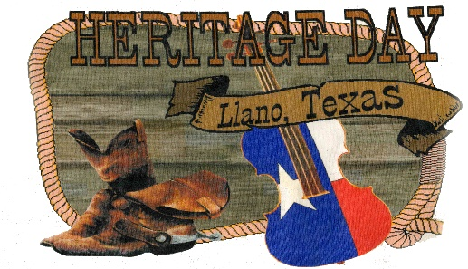2024 Sponsorship Agreement
Thank you for your support of Llano Heritage Days Festival
October 18-20, 2924
Sponsor Name:___________________________________________________
Contact Person:___________________________________________________
Address:_________________________________________________________
Phone:_________________ E-mail:___________________________________
Signature:________________________________________________________
SPONSORSHIP SELECTION
( ) Corporate Sponsor - $1,000.00 +
Name and logo on Main Stage banner, all printed materials, website, facebook, name
announced throughout the festival, can give out promotional materials
( ) Gold Sponsor - $500.00+
Name and logo on all printed materials, website, facebook, name announced throughout
the festival
( ) Silver Sponsor - $300+
Name and logo on website, facebook, name announced throughout the
( ) Bronze- $100.00+
Name and logo on website, facebook
( ) Other $________
PLEASE RETURN COMPLETED FORM and PAYMENT TO: CHECKS PAYABLE TO:  Llano County Historical Museum  PO Box 434  Llano, Tx 78643 | ARTWORK REQUIRENTS  Website – Images must be jpg or png format  Print – Images must be high resolution pdf format  Artwork Due By August 30, 2024  Email to: cristele.richins@gmail.com

